**Event-Based Control**

**Rui Carapinha 248728**

**Second Task**

The second task was to control two car, with a controller (represented by the lights). The car can only enter the tunnel when the traffic light is green.

Tunnel

Controller

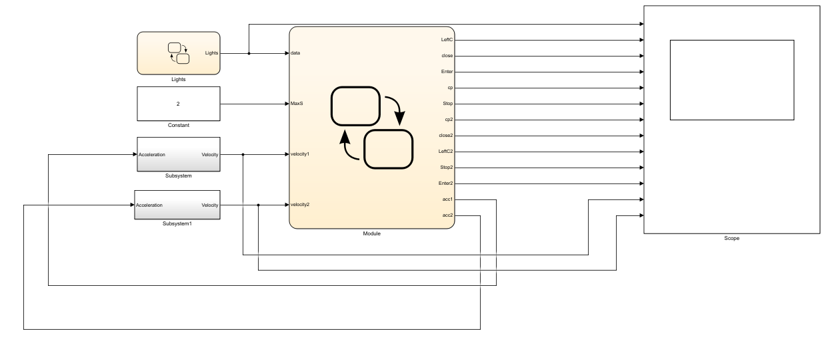To do this I made a program with SimuLink and StateFlow scripts. This program consists in two StateFlow graphs, one to control the “lights” and the other to control the rest of the logics involving the two cars movement. The global graph is the following:

The first graph, Lights, is the following:

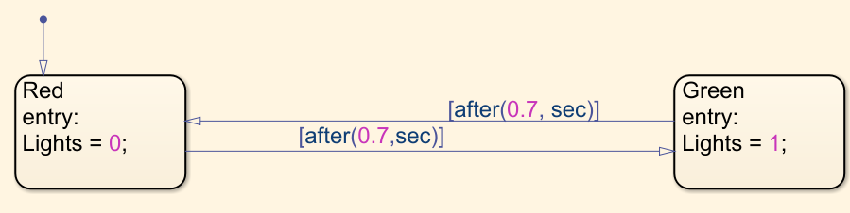

This graph works like a clock, the controller (inside the other StateFlow chart, is one that controls the entry or not of car 1 or 2 in the tunnel).

The second graph, Module, is split in 3 parts, two for each car and one for the controller. The car module is the next:

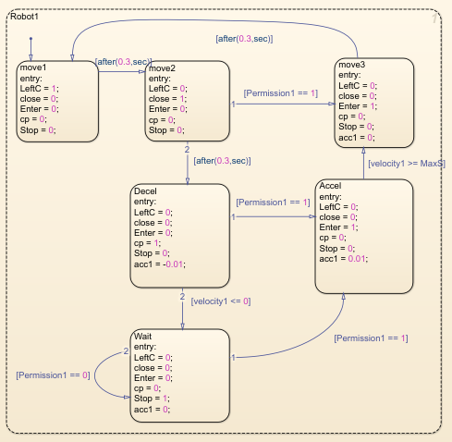

This graph is equal for the two cars. The initial state is that the car is doing the circle. Then the car will get close to the tunnel and wait for the permission. If the car doesn’t as permission to enter the tunnel it will start to slow down. If meanwhile he receives permission to enter it will start to accelerate till it reaches the top speed. If the car doesn’t receive the permission it will stop and wait for the permission to enter. This logic applies for both the cars.

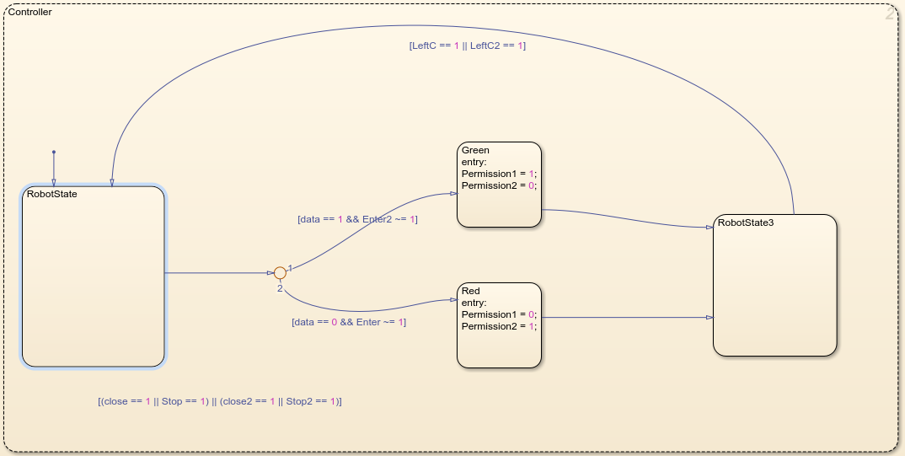The controller graph is the following:

The goal of the controller is to make sure only one car is in the tunnel. There can’t be two cars in the tunnel at the same time. To do this, every time the controller sees someone is stopped or someone is close to the tunnel it will check if any car is in tunnel and check if the controller can give permission or not.

The velocity of the car is given by the SimuLink block. The SimuLink block is the following:

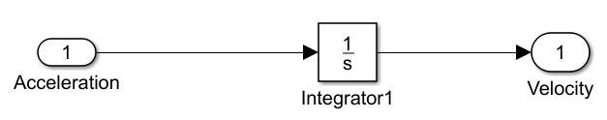

It’s a pretty simple block, that gives us the velocity of the car.

The results were the following:

For Car 1:

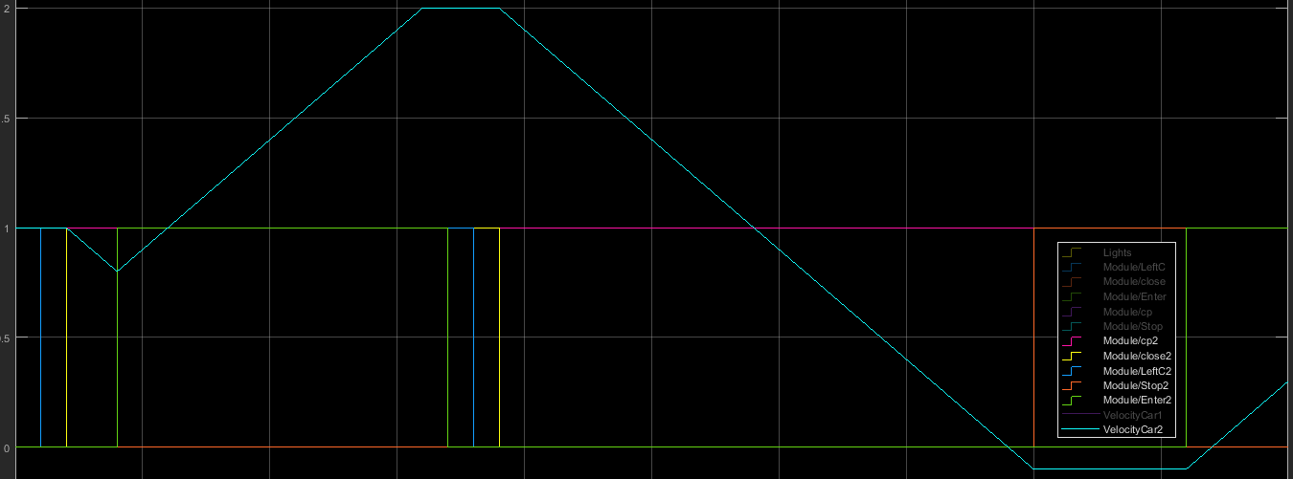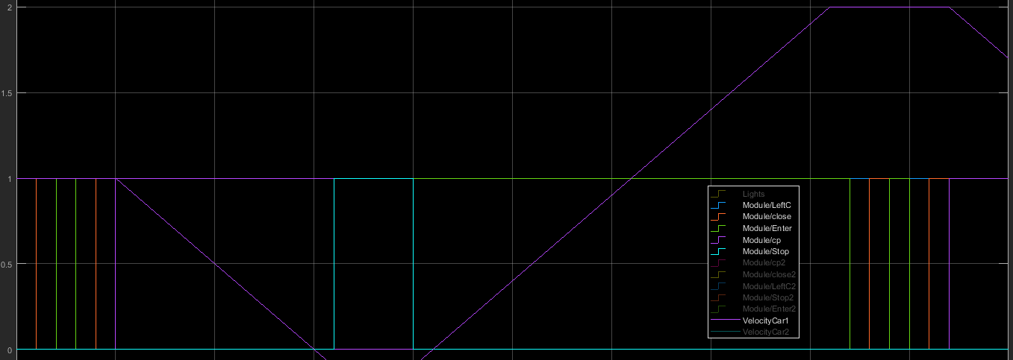And for car 2:

As we can see there is only one car in the tunnel at the same time. The top picture is for car 1 and the bottom picture is for car 2:

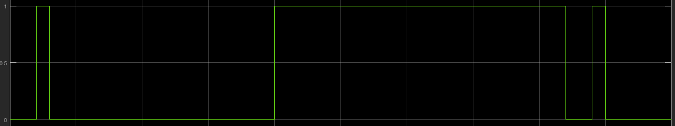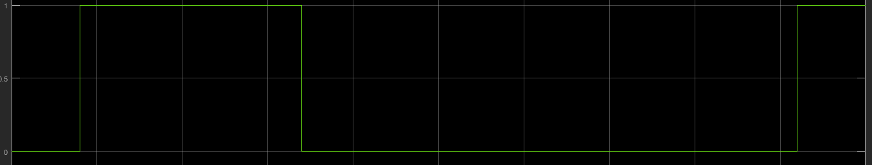

We can see by the results that the problem was well solved. I only had one problem with the acceleration that I couldn’t fix. The down bottom of the velocity should be 0 but it’s a bit lower than that.